**Project Deliverable 3 – User Manual**

**Faculty Name:** Information Technology

**Module Code:** ITECA3-B12

**Module Name:** Web Development and e-Commerce

**Content Writer:** Sandile Dlamini

**Copy Editor:** Mr Kyle Keens

**Submission Date:** Block 2 Week 5

|  |  |
| --- | --- |
| **Student Name** | Modisaotsile Modiselle |
| **Student Number** | hq9sj1j57 |
| **Project Title** | Bride&Joy |
| **Submission Date** | 21 June 2024 |

**Table of Contents**

3.1 Introduction 3

3.2 Basics: Accessing your website and Admin 3

3.3 Products: Adding, removing, and updating products 5

3.4 Changing menus 5

3.5 Shipping Options 7

3.6 The front page: adding and changing images 8

3.7 Orders 9

3.8 Updating a page on your site 11

3.9 Collecting money from the store 11

3.10 Checking Web Traffic and Statistics 11

3.11 Appendix 12

# Introduction

**3.1.1 Background**

Our customer, Sandy Hurynarin, ran a side hustle selling wedding attire firstly to family members. This side hustle grew to selling to friends and other customers through word of mouth. She eventually opened up a store in her home town in KwaZulu-Natal.

We approached her about building a site for her business, and she was more than happy to participate. He vision was to having something the likes of Superbalist.com, where customers could buy wedding clothes safe in the knowledge they could find a suitable size, and even return the goods through the site if necessary. After some negotiation, the list of requirements was shortlisted and incorporated into a final product.

**3.1.2 About this website**

The site uses PHP to orchestrate many different parts into a final product. The parts where built with semantic HTML in mind to help with search engine optimization. Semantic HTML is technique of using appropriate HTML elements to describe a website, as opposed to using generic <div> and <p> elements as building blocks. That is, the pages are composed of <header>, <main>, and <footer> elements to divide the pages. Those page components are themselves composed of sub elements, <section>, <nav>, <figure>, etc. elements to further describe them.

JavaScript is scattered throughout the site to handling client-side responsiveness in areas such as input validation, button action triggering, and general animation. Lastly, plenty of CSS is employed to achieve an elegant and appeal look and feel for user.

Due to various schedule and administrative changes, an additional responsive version of the site was commissioned for the client.

# Basics: Accessing your website and Admin

**3.2.1 Accessing the website**

We utilized the webhosting services of 000Webhost(Hoststinger) to handling the website’s files. The domain accessible to customers is.

<https://sandybrown-hamster-605814.hostingersite.com/>

**3.2.2 The Admin Area**

The admin area is provided by Hostinger. It is a phpMyAdmin interface wherein the database can be tables can be view and altered. Below is a screenshot of the stock table.

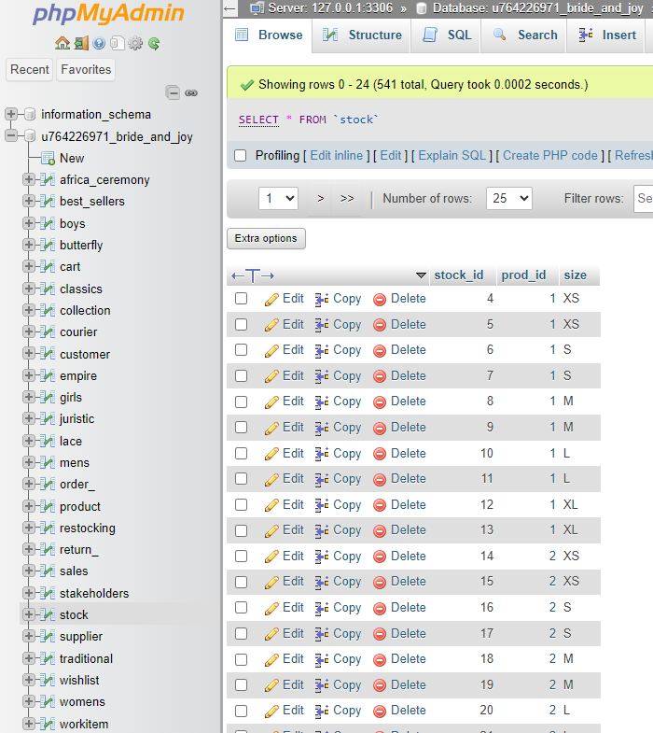

# Products: Adding, removing, and updating products

**3.3.1 Adding and Removing Products**

The image above displayed the stock table with individual items. The interface provides buttons to either copy specific records (but for their stock_id primary key) or delete them. The interface also provides areas for manually writing INSERT SQL statements,

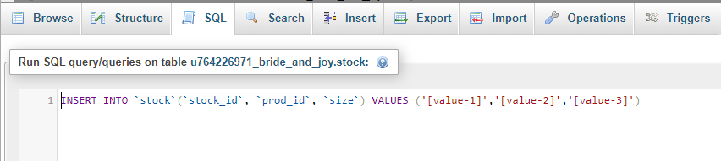

Or plugging and playing table values.

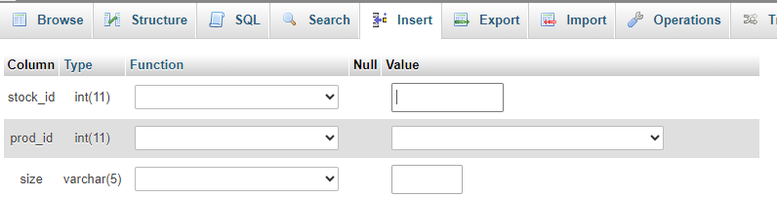

**3.3.2 Updating Products**

Refer to figure 1, where the relevant Edit button is evident for modifying particular product fields.

# Changing menus

Before logging in or signing up, the user is prompted to do either one in the website’s navigation menu.



Once the user has logged in or signed up, the navigation menu changes to display any saved collection of items, the option of accessing a profile, or simply logging out.



Once an item is added to cart, a total and checkout button appear.

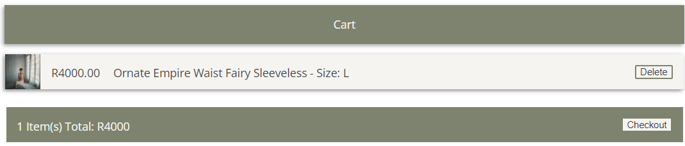

Once the cart item(s) are deleted, the cart menu page changes accordingly.

JavaScript is used to achieve an accordion effect on the profile data edit screen.

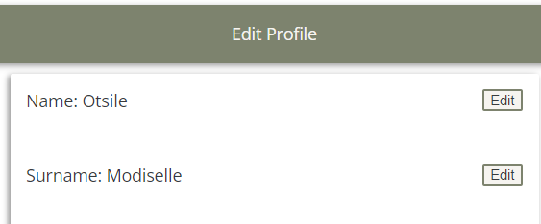

That is, clicking the edit button uncovers an input section with validation also handled by JavaScript.

Once the input is acceptable and saved, the profile edit menu displays the updated value pulled from the database.

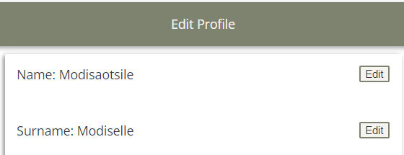

# Shipping Options

The website states presents that all purchases of at least R1000 enjoy free shipping.

Once a carted item is checked out, the user is brought to the order checkout screen.

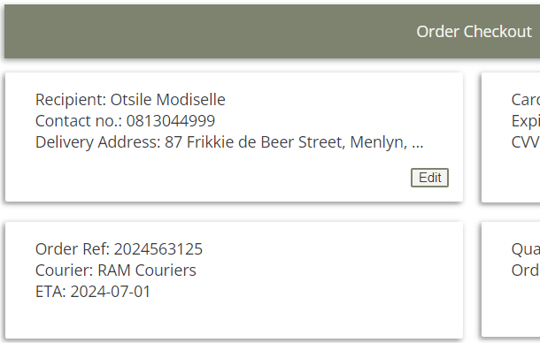

Here, the user is presented an opportunity to update their delivery recipient, their contact number, and address if these details were not already updated. The logic behind the shipping, courier selection, fees, and estimated (10 days from current date) is kept from the user for convenience. Only their material facts are presented.

# The front page: adding and changing images

The website uses a carousel of some clickable product images that redirect to the product pages.

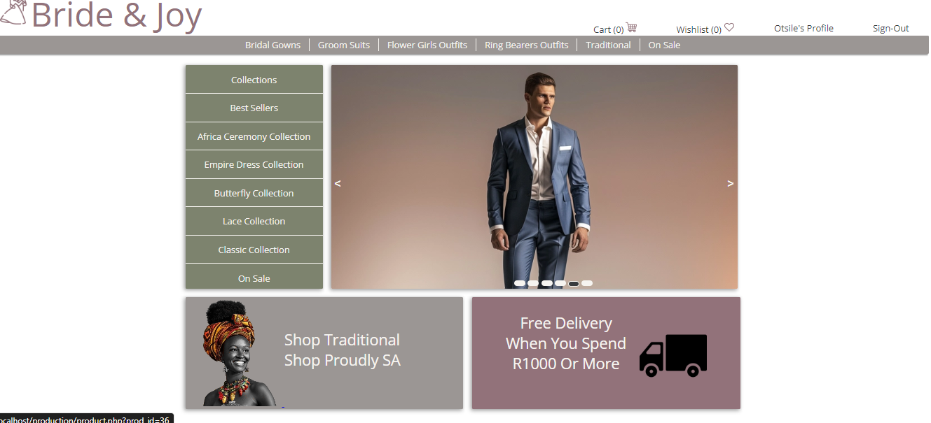

# Orders

A user must first identify an outfit, select a size and add it to cart.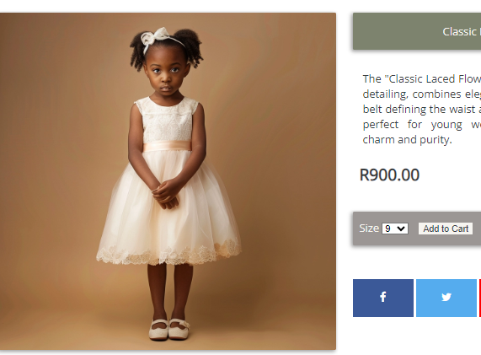

Once added to cart, the user must checkout the item to before paying.

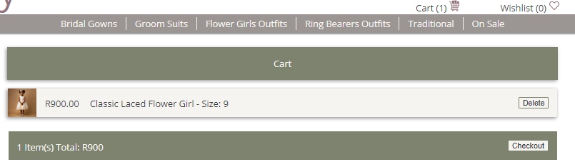

The cart is then emptied, and an order is created. A courier is populated, and a delivery time estimated. The user must confirm delivery and payment information before making payment.

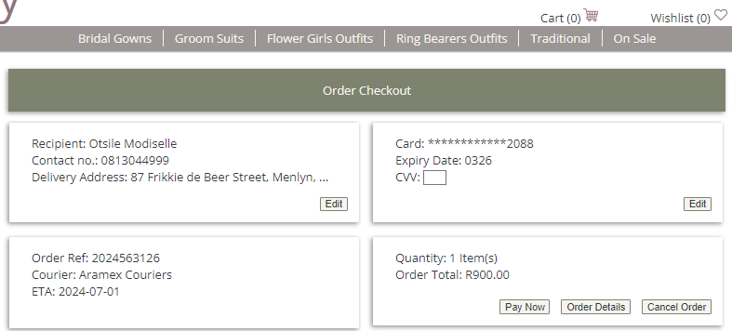

Once payment is made, and confirmation message appears.

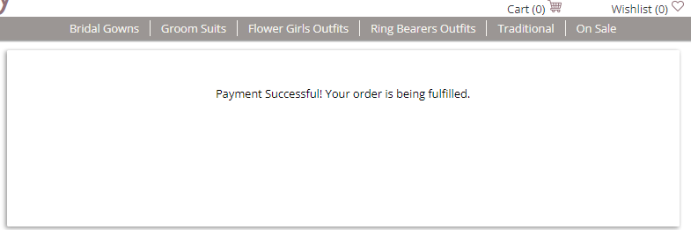

The user can review past orders, and complete or cancel unfinished orders under their profile page.

# Updating a page on your site

The customer has agreed to let the writer work as webmaster. Pages will be uploaded to Hostinger’s file manager tool with relevant recoding to integrate them to the site’s flow.

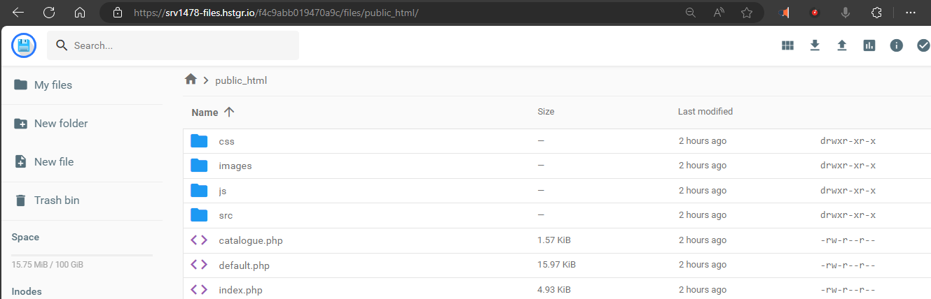

# Collecting money from the store

The site currently accepts card payments.



# Checking Web Traffic and Statistics

Hostinger offers a performance hub for monitoring analytics.

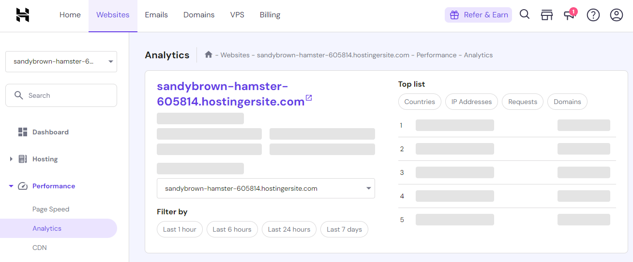

# Appendix

The site is a composition of files uploaded to hosting site Hostinger. The files are accessible through an open git repository at

https://github.com/otsilemodiselle/ITECA_Project